

Name: Maheen Tokir
Registration Number: FA23-BCS-041
Internship Organization: Askari bank (IT HUB )
Team: IT Operations Team
University Supervisor: Sir Mukhtiar Zamin
External Supervisor: Sir Kashif Siddique
Week: 1
Reporting Period: January 19, 2026 -- January 23, 2026

Objectives for the Week
• To understand the basic working of IT infrastructure in a banking environment
• To observe system administration and network management tasks
• To learn how security, monitoring, and maintenance are handled in bank systems
• To gain practical exposure to hardware, software, and domain-based operations

Tasks and Activities Performed

Day 1 – 3
• Observed different computer hardware components and display connectivity options such as VGA and HDMI
• Learned the purpose of disk creation and partitioning for organizing system and user data
• Understood the process of renaming computers to follow organizational naming standards
• Observed system logs and user activity records used for monitoring and security compliance
• Visited the IT room and studied network infrastructure including switches, routers, firewalls, patch panels, UPS units, and structured cabling
• Learned how bank branches and remote systems are connected securely through network devices

Day 4 – 5
• Executed and analyzed Windows diagnostic and maintenance commands such as:
- temp and %temp% for clearing temporary files
- prefetch for resolving cached data issues
- ipconfig for checking network configuration
- wmic bios get serialnumber for system identification
• Observed installation and configuration of essential banking software including:
- Oracle Database and Microsoft SQL Server
- Core Banking System (CBS)
- Kaspersky Endpoint Security
- DNS and DHCP services
- Active Directory for domain and user management
• Learned how printers, scanners, and biometric devices are configured and connected within the network
• Observed the process of diagnosing hardware faults, including RAM and hard drive checks
• Learned troubleshooting techniques for black screen and boot issues using recovery options and bootable USB devices
• Understood the importance of data backup and storing user data on separate drives
• Observed the process of adding computers to the bank’s domain and managing user access through group policies
• Learned how browser bookmarks are exported and imported during system migration

Tools / Technologies Used
• Hardware: Desktop systems, monitors, LAN cables, switches, routers, UPS devices, firewalls
• Operating Systems: Windows (client and server editions)
• Commands & Utilities: temp, %temp%, prefetch, ipconfig, wmic, Automatic Repair tools
• Software: Oracle Database, Microsoft SQL Server, Core Banking System, Active Directory
• Security Tools: Kaspersky Endpoint Security
• Devices: Printers, scanners, biometric systems

Weekly Learning Outcomes
• Developed a basic understanding of banking IT infrastructure and operations
• Learned how system administration tasks are performed in a domain-based environment
• Understood how logs and monitoring enhance security and compliance
• Gained exposure to real-world hardware troubleshooting procedures
• Learned the role of networking devices in maintaining secure and reliable banking services
• Improved understanding of data backup, domain management, and system recovery techniques

Appendix – A (Supporting Evidence)
Figure 1: Random Access Memory (RAM) installed on the motherboard during system inspection
Figure 2: Hard drive partitioning interface showing multiple volumes used to organize operating system and user data for efficient storage management

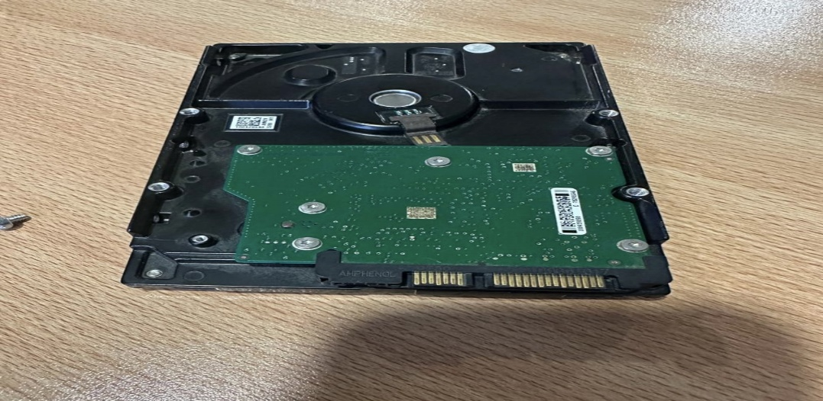
FIGURE 1:Random Access Memory (RAM) module installed on the motherboard, responsible for temporarily storing data and instructions required for active system processes

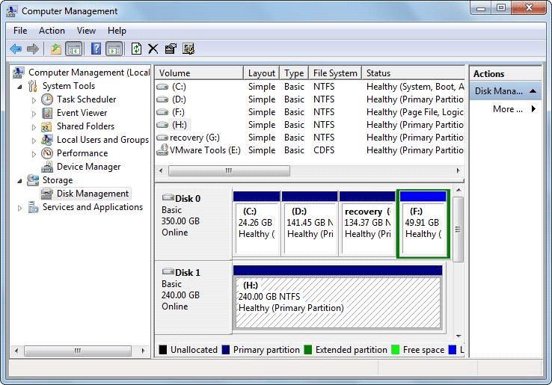
FIGURE 2:Disk partitioning interface showing multiple volumes on a hard drive, used to organize system and user data for efficient storage management

